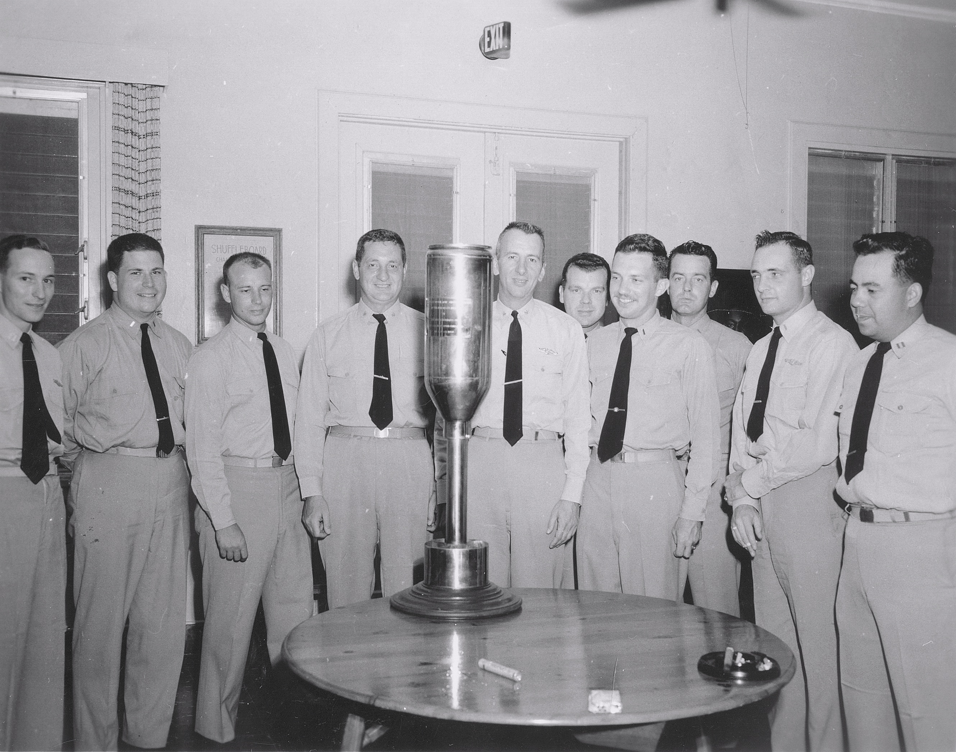
USS ARCHERFISH (SS 311) OFFICERS WITH U.S. COAST GUARD CUTTER OFFICERS IN GITMO, CUBA O’CLUB PRESENTING CHROME PLATED HEDGE HOG TO CUTTER. PRACTICE HEDGE HOG WAS FOUND ON ARCHERFISH DECK UPON COMPLETION OF ASW EXERCISES WITH CUTTER – DATE CIRCA SUMMER 1958
Al (Sam) Houston
C.O. Charlie Beck
X.O. Pete Poteet
Jim McDermott
Joe Kronzer
Steve Ramos
(ARCHERFISH OFFICERS PRESENT IDENTIFIED. MISSING WERE “WHITEY” PLATT AND LES BANGHART)

